Responsive web design is needed to give the user a better, real-time experience as the website should be something more than a blog-site. It also gives the website more uses other than being a wall of text.

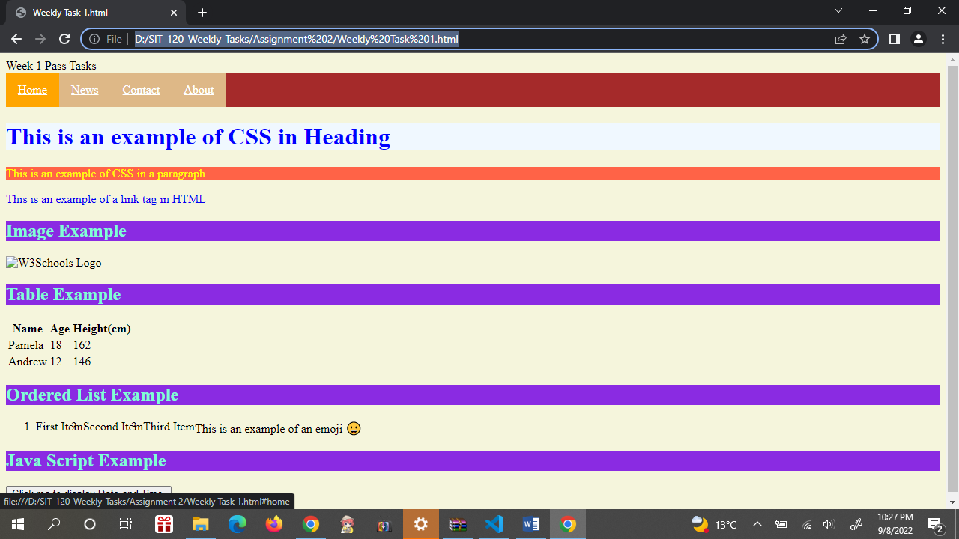

A responsive design with CSS include a navigation bar and it needs a separate stylesheet in order to work best. In the main html file, the programmer can include the list for the navigation bar, and then modify the style of the list in the stylesheet.